Below is a graph of the simulated acceleration data and of the experimental acceleration data:

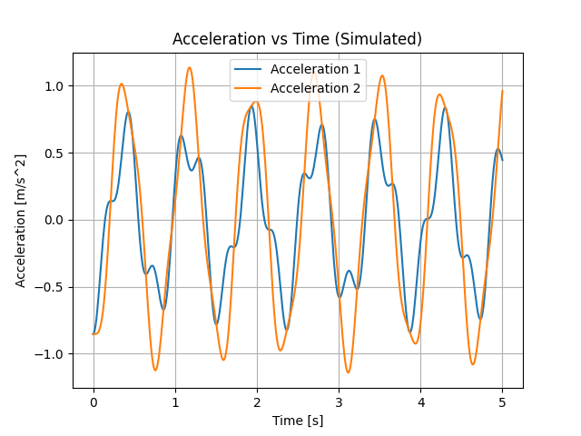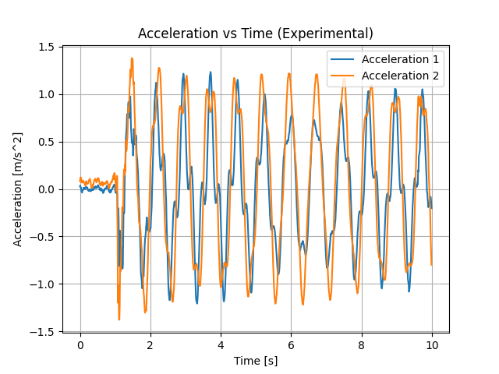

|  |  |
| --- | --- |
| **Two-Story System Parameters** | |
| **Parameter** | **Value** |
| Mass M1 | 0.656 grams |
| Initial X1 | 1 cm |
| Stiffness K1 | 111 N/m |
| Damping B1 | 0.001 N * s/m |
| Mass M2 | 0.656 grams |
| Initial X2 | 0.5 cm |
| Stiffness K2 | 111 N/m |
| Damping B2 | 0.001 N * s/m |

To calculate the masses, M1 and M2, we measured the mass of the entire system and divided it by 3. In doing so, we neglected the mass of the springs and assumed each of the levels was equivalent in mass.

We initially offset the top mass, M1, by a value of 1cm, and the bottom mass, M2, by a value of 0.5 cm. This gave us the initial parameters X1 and X2, respectively.

To calculate the stiffness of the springs, we utilized Burr’s equations, measuring the force applied to the mass and its displacement, v2. We applied a force of 5N, and the resulting displacement v2 was 4.5 cm, giving us a spring constant of 111 N/m.

For the damping coefficients, B1 and B2, we assumed a low value of 0.001 N*s/m.



|  |
| --- |
| **Eigenvalues** |
| -0.00201387+21.144258j |
| -0.00201387-21.144258j |
| -0.00029382 +8.07638792j |
| -0.00029382 -8.07638792j |

**Eigenvectors**

$$\left[\begin{matrix}3.821×{10}^{-6}+4.011×{10}^{-2}j & 3.821×{10}^{-6}-4.011×{10}^{-2}j & -2.361×{10}^{-6}- 6.491×{10}^{-2}j & -2.361×{10}^{-6}+6.491×{10}^{-2}j \\ 0.848 & 0.848 & 0.524 + 2.389×{10}^{-20}j & 0.524 + 2.389×{10}^{-20}j \\ -6.182×{10}^{-6}- 6.491×{10}^{-2}j & -6.182×{10}^{-6}+ 6.491×{10}^{-2}j & -1.459×{10}^{-6}- 4.011×{10}^{-2}j & -1.459×{10}^{-6}+4.011×{10}^{-2}j \\ 0.524+4.695×{10}^{-20}j & 0.524-4.695×{10}^{-20}j & 0.848 & 0.848\end{matrix}\right]$$

**Solving for $ω_{n}$**

$$3.821 ×{10}^{-6}= -ζω_{n}$$

$4.011 ×{10}^{-2}= ω_{n}\sqrt{1-ζ^{2}}$

­

Using systems of equations, solve for $ω_{n}$:

$ω_{n}=0.04011 Hz$